**Evidence that show Application Support team members receive MIR3, email, o other notifications due to a failure or Abend**

**Failure**:

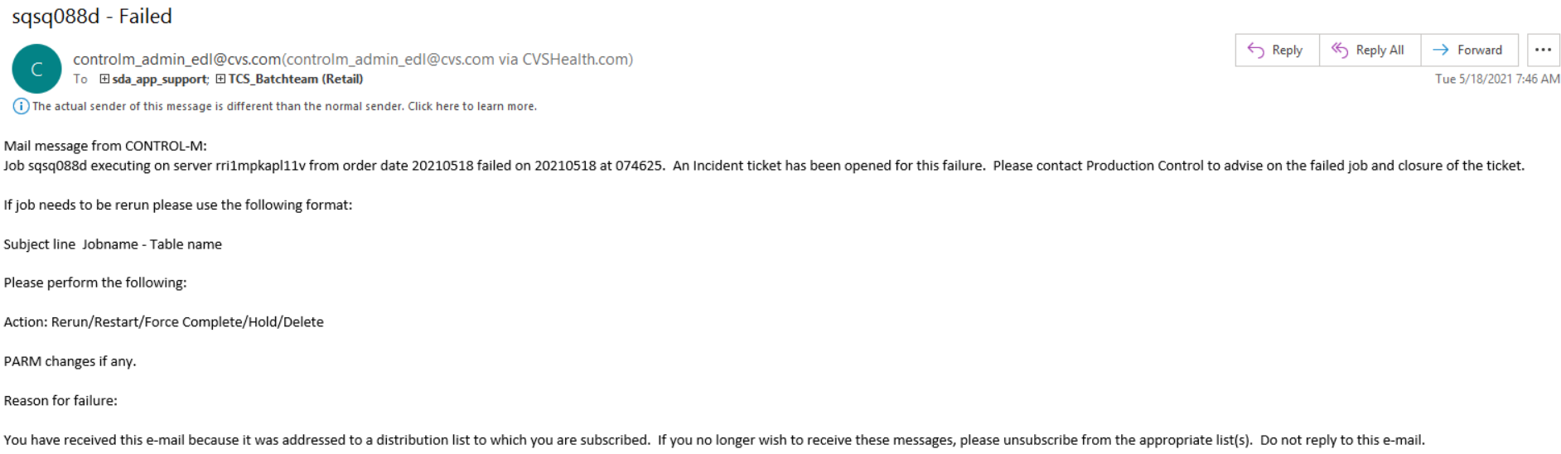

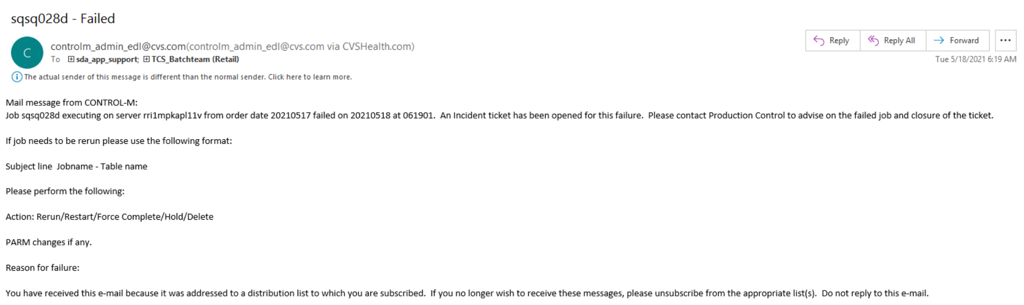

**Late Shout**:

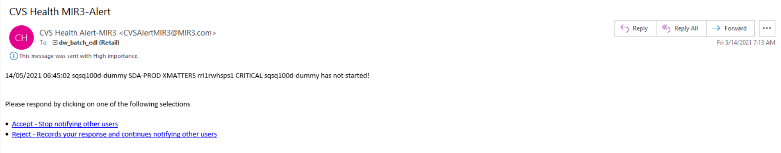

**Based on the failures, provide evidence that show Application Support Team received notification from Operations Support Staff (OSS) for triaged batch job failures/abends, when required**

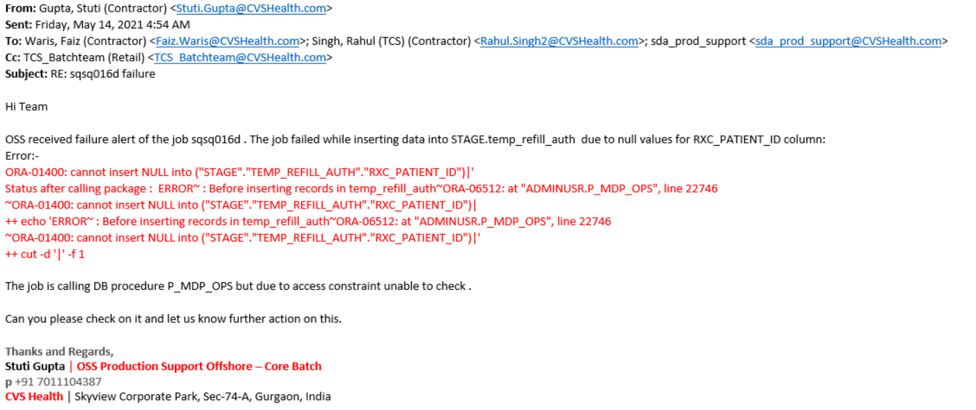

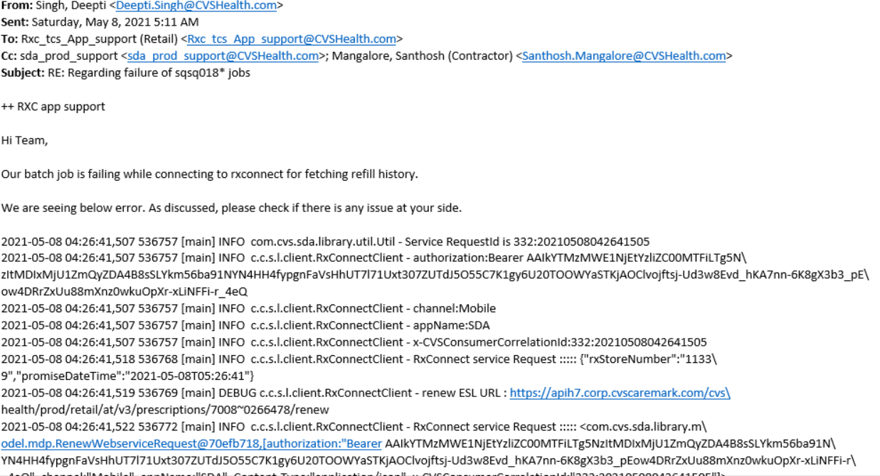

**Evidence showing Job failures are addressed according to standards**

* Below is mail related to recovery of **sqsq016d** failure.



* Below is the mail related to recovery of **sqsq028d** failure

